Github: https://github.com/NCBI-Codeathons/beyond-phylogenies-team3

**Nate: Front-end development of phylogenetic display**

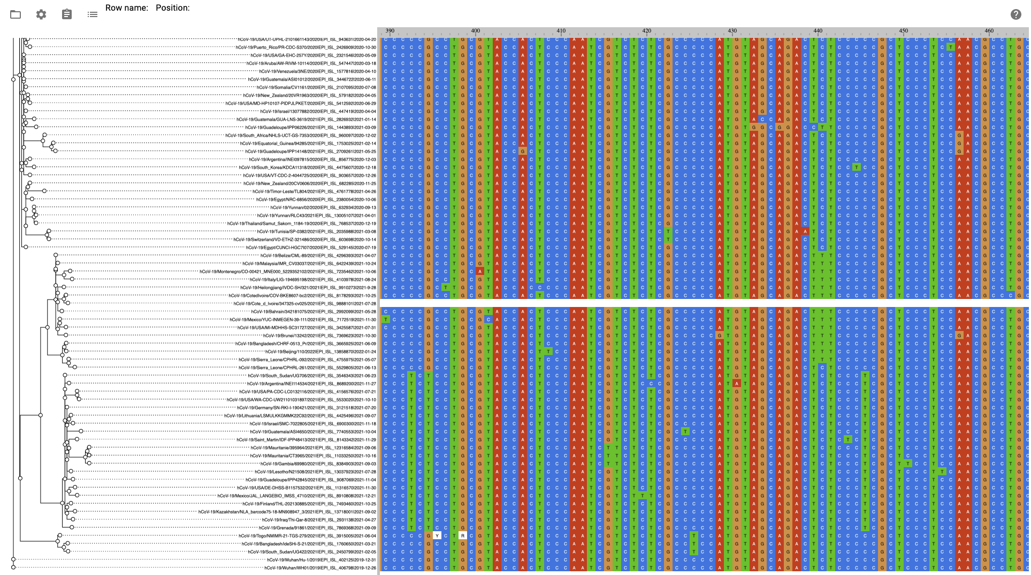

Enabled loading and display of phylogeny and VCF directly from file. Straightforward for phylogenetic tree; loading of VCF entails generating pseudo alignment containing only variable sites. Also addressed feedback from presentation yesterday on confusing color scheme.

**Chrissy & Daniel: File uploading and parsing**

